WATER STRESS STUDY IN INDIA
India, a nation of immense geographical diversity and a burgeoning population, faces a significant challenge in the form of water stress. This isn’t merely a localized issue but a pervasive problem with far-reaching implications, particularly for its burgeoning industrial sector. Understanding the nuances of water stress in India requires a deep dive into its current challenges and the specific ways in which industries are both contributing to and being affected by this scarcity.
Water stress occurs when the demand for water exceeds the available supply over a given period, or when poor quality restricts its use. For India, this definition resonates broadly. The country, despite possessing approximately 18% of the world’s population, has access to only about 4% of the world’s renewable freshwater resources. This disproportionate distribution forms the bedrock of its water stress narrative.
Several factors contribute to this precarious balance. Erratic monsoon patterns, exacerbated by climate change, lead to extended dry spells in some regions and devastating floods in others, disrupting traditional water availability cycles. Furthermore, groundwater, a vital resource for both agriculture and urban consumption, is being extracted at unsustainable rates. The Central Ground Water Board (CGWB) has repeatedly highlighted falling water tables across various states, painting a stark picture of depletion. This extensive reliance on groundwater, often unregulated, acts like drawing from a finite well without proper replenishment.
The sheer scale of India’s population also places immense pressure on existing water resources. Growing urbanization and demographic shifts mean more people vying for the same diminishing supply. This complex interplay of climatic variability, over-extraction, and population growth creates a multifaceted water stress problem that demands a comprehensive and proactive approach.
Defining Water Scarcity vs. Water Stress
It’s crucial to differentiate between water scarcity and water stress. While often used interchangeably, they represent distinct stages of a problem. Water scarcity is a more absolute term, referring to a physical lack of sufficient freshwater resources to meet demand. This can be due to natural aridity or severe depletion. Water stress, on the other hand, describes a situation where the availability of fresh water is limited enough to cause adverse effects on human health, economic development, or the environment. India, while facing absolute scarcity in some regions, predominantly grapples with systemic water stress across its diverse landscapes.
Regional Disparities in Water Availability
The tapestry of India’s geography mirrors its water situation. Some regions, particularly in the northern plains fed by Himalayan rivers, traditionally benefit from relatively abundant surface water. However, even these regions face challenges due to pollution and inefficient water management. Conversely, western and southern states, characterized by arid and semi-arid climates, confront chronic water shortages. States like Rajasthan and parts of Maharashtra, Karnataka, and Tamil Nadu are frequently cited as experiencing severe water stress. This disparity necessitates regionally tailored solutions rather than a one-size-fits-all approach.
In the context of addressing water stress in India, it is essential to consider the broader implications of resource management across various sectors, including energy consumption. A related article that delves into the energy audit conducted for a Mahindra dealership in Kolkata highlights the importance of efficient resource use in industries that are often heavily reliant on water. For more insights on how energy efficiency can play a role in mitigating industrial impacts on water resources, you can read the article here: Energy Audit for Mahindra Dealership in Kolkata.
Industrial Impact: A Double-Edged Sword
Industries, the engines of economic growth and employment, are inextricably linked to India’s water stress narrative. They are significant consumers of water, particularly in sectors like thermal power generation, textiles, and manufacturing. However, their impact isn’t solely confined to consumption; industrial waste discharge often contributes to water pollution, further exacerbating the problem by rendering existing water sources unusable.
The industrial sector’s role is a double-edged sword. While it drives prosperity, its water footprint demands careful scrutiny. Imagine a sprawling factory that requires vast amounts of water for cooling and processing. This demand, when multiplied across thousands of industries, quickly adds up, drawing heavily from already overstretched water resources.
Water-Intensive Industries and Their Footprint
Several industrial sectors stand out for their substantial water consumption.
- Thermal Power Plants: These plants, which generate the majority of India’s electricity, are by far the largest industrial consumers of water. They use vast quantities for cooling purposes, often drawing from freshwater sources. The inefficiencies in cooling technologies in many older plants further compound the issue.
- Textile Industry: From dyeing and cleaning to finishing, textiles are notoriously water-intensive. The vibrant colors that adorn our clothes often come at a significant water cost, with millions of liters used per ton of fabric produced. Moreover, the discharge of untreated wastewater from textile units is a major source of river pollution.
- Paper & Pulp Industry: The production of paper requires substantial amounts of water, both for processing wood pulp and for chemical treatments. Like textiles, effluent discharge from this industry often contains harmful pollutants.
- Sugar Industry: As an agro-based industry, sugar production relies heavily on water for sugarcane cultivation and then for processing the cane into sugar. The discharge from sugar mills can also be highly polluting if not treated adequately.
- Pharmaceutical Industry: While perhaps less visible than other sectors, pharmaceutical manufacturing also utilizes considerable water in various stages, from research and development to production and cleaning. Effluent from this sector can contain complex chemical compounds that are challenging to treat.
These industries, while vital for the economy, represent significant pressure points on India’s freshwater reserves. Their operational models often predate the current understanding of acute water stress, making adaptation a critical challenge.
Pollution and Effluent Discharge
Beyond direct consumption, industrial pollution significantly amplifies water stress. When industries release untreated or inadequately treated wastewater into rivers, lakes, and groundwater, they effectively reduce the usable water supply. This chemical and organic contamination poses severe health risks to communities downstream and disrupts aquatic ecosystems. The ‘clean Ganga’ initiative, for instance, highlights the monumental task of rejuvenating rivers polluted by a multitude of sources, including industrial effluence. This pollution acts like a poison, making an already scarce resource even scarcer by rendering it unfit for consumption or other uses.
Economic Ramifications of Water Scarcity for Industries
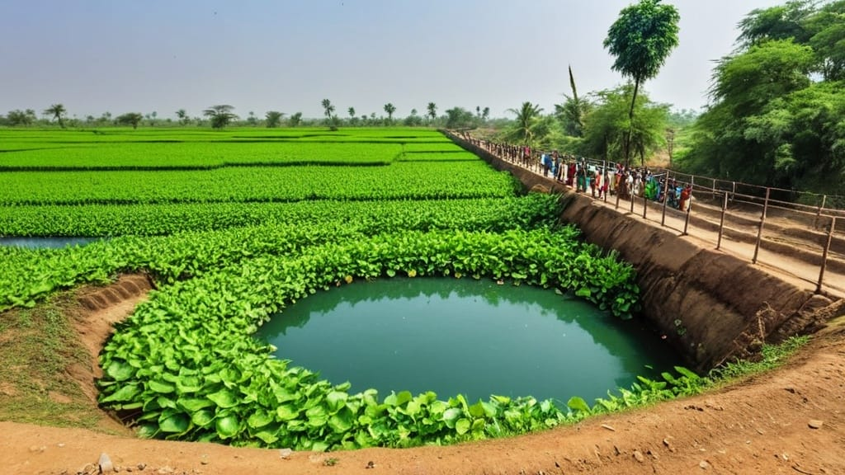
The impacts of water stress on industries are not abstract; they translate directly into tangible economic consequences. Imagine a factory forced to halt production due to a lack of water, or facing steep fines for exceeding its water usage limits. These scenarios are becoming increasingly common.
Production Disruptions and Operational Costs
Water unavailability can lead to severe production disruptions, forcing industries to scale back operations or even temporarily shut down. This directly impacts output, revenue, and profitability. Furthermore, as freshwater becomes scarcer, its cost increases. Industries are forced to invest in alternative water sources, such as desalination or advanced wastewater treatment, which entail significant capital and operational expenditures. This rise in input costs can erode profit margins and make products less competitive. A factory that once relied on readily available river water might now need to truck in water from distant sources, incurring substantial transportation costs, effectively adding layers to its operational burden.
Reputation and Investor Confidence
In an era of increasing environmental awareness, a company’s water stewardship practices are under scrutiny. Industries perceived as irresponsible water users face reputational damage, which can lead to consumer boycotts, difficulty in attracting talent, and decreased investor confidence. Financial institutions are increasingly incorporating environmental, social, and governance (ESG) factors into their investment decisions, making sustainable water management a critical aspect of corporate viability. Companies with poor water records risk being seen as high-risk investments, potentially limiting their access to capital and hindering future growth.
For businesses looking to optimize their water usage, conducting a Water Audit is an essential step.

Policy, Regulation, and Mitigation Efforts
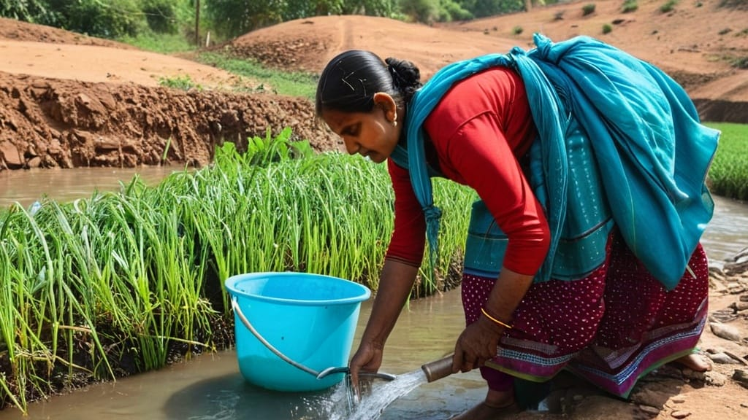
Recognizing the severity of the water crisis, the Indian government has initiated various policies and regulatory frameworks aimed at sustainable water management. These efforts, while ambitious, face challenges in implementation and enforcement.

Government Initiatives and Regulatory Frameworks
The Jal Jeevan Mission, an ambitious central government scheme, aims to provide safe and adequate drinking water through individual household tap connections to all rural households by 2024. While primarily focused on drinking water, its underlying principles influence overall water resource management. The National Water Policy (2012) emphasizes integrated water resource management, prioritizes drinking water and irrigation, and promotes efficient water use.
Regulatory bodies like the Central Pollution Control Board (CPCB) and various State Pollution Control Boards (SPCBs) are tasked with setting effluent discharge standards and monitoring compliance. The Environmental (Protection) Act, 1986 provides the legal framework for these regulations. Lately, there has been an increased focus on effluent treatment plant (ETP) mandates and zero liquid discharge (ZLD) technologies for highly polluting industries. This push for ZLD, where all wastewater is treated and reused within the industrial premises, represents a significant shift towards circular water management.
Industrial Best Practices and Technological Solutions
Industries themselves are increasingly adopting best practices and technological solutions to mitigate water stress.
- Water Audits and Efficiency Measures: Conducting regular water audits helps industries identify areas of excessive consumption and inefficiency. Implementing measures like leak detection, process optimization, and using water-efficient machinery can significantly reduce their water footprint.
- Wastewater Treatment and Recycling: Investing in advanced effluent treatment plants (ETPs) and sewage treatment plants (STPs) allows industries to treat their wastewater to a reusable standard. Treated water can then be recycled for non-potable purposes, such as cooling, cleaning, or even process water in some cases.
- Rainwater Harvesting: Many industries are installing rainwater harvesting systems to capture and store precipitation, reducing their reliance on municipal or groundwater sources. This acts as a localized, sustainable water source.
- Adoption of Zero Liquid Discharge (ZLD): For particularly water-intensive and polluting industries, ZLD systems are becoming increasingly prevalent. These advanced systems treat and recover almost all wastewater for reuse, minimizing discharge to external environments. While capital intensive, ZLD offers long-term sustainability benefits and regulatory compliance.
- Industry Collaboration and Water Stewardship: Collaborative efforts, such as industrial clusters pooling resources for common effluent treatment plants, can improve efficiency and reduce individual burdens. Engaging in water stewardship programs helps industries assess their water risks, set targets, and transparently report their performance.
These proactive steps demonstrate a growing recognition within the industrial sector that water is not an infinite resource but a critical input requiring careful management.
In exploring the critical issue of water stress in India, it is essential to consider the broader implications on various sectors, including industrial operations. A related article discusses the importance of fire safety audits in ensuring secure workplaces, which can be impacted by water availability and management. Understanding how water stress affects industrial safety protocols can provide valuable insights into the challenges faced by businesses today. For more information on this topic, you can read the article on fire safety audits here.
The Path Forward: Towards Water Security and Sustainability
Metric | Value | Unit | Description
Percentage of Population Facing Water Stress | 54 | % | Proportion of India’s population living in water-stressed regions
Annual Water Demand | 1,123 | km³ | Estimated total water demand in India by 2050 205
Industrial Water Usage | 22 | % | Percentage of total water consumption attributed to industries
Groundwater Depletion Rate | 3.5 | cm/year | Average annual decline in groundwater levels in critical zones
Water Recycling in Industries | 15 | % | Average percentage of water recycled and reused by industries
Number of Water-Stressed Districts | 256 | Districts | Districts classified as water-stressed or water-scarce
Impact on Industrial Output | 8 | % | Estimated reduction in industrial output  due to water shortages
Investment in Water Efficiency Technologies | 120 | Million INR | Annual investment by industries in  water-saving technologies
India’s journey towards water security is multifaceted, requiring a sustained and coordinated effort from all stakeholders. Addressing water stress is not a singular event but a continuous process of adaptation, innovation, and effective governance.
Integrated Water Resource Management
Moving forward, an integrated approach to water resource management is paramount. This involves considering surface water, groundwater, and wastewater as interconnected components of a single system. Policies must reflect this holistic view, promoting efficient allocation across sectors – agriculture, domestic, and industrial – while prioritizing ecological balance. This means breaking down the silos that often separate water management strategies for different uses.
Investment in Infrastructure and Innovation
Significant investment is needed in water infrastructure, including modern irrigation systems to reduce agricultural water waste, efficient municipal water distribution networks to minimize leakage, and advanced wastewater treatment facilities. Furthermore, fostering innovation in water-efficient technologies, desalination techniques, and groundwater replenishment methods will be critical. This calls for increased public and private sector collaboration in research and development.
Public Awareness and Behavioral Change
Ultimately, water conservation is a collective responsibility. Raising public awareness about the severity of water stress and promoting behavioral changes – from reducing household water consumption to demanding sustainable practices from industries – is crucial. A well-informed populace is more likely to support and participate in water conservation efforts. For industries, this means cultivating a culture of water consciousness, embedding efficient water use into every process, and actively contributing to local water stewardship initiatives. No single entity can solve this challenge alone, and the future of India’s water security lies in a collaborative and sustained commitment to its most vital resource.

